|  |
| --- |
| [Type the company name] |
| 7 mindset to life improvement |
|  |
|  |
|  |
|  |

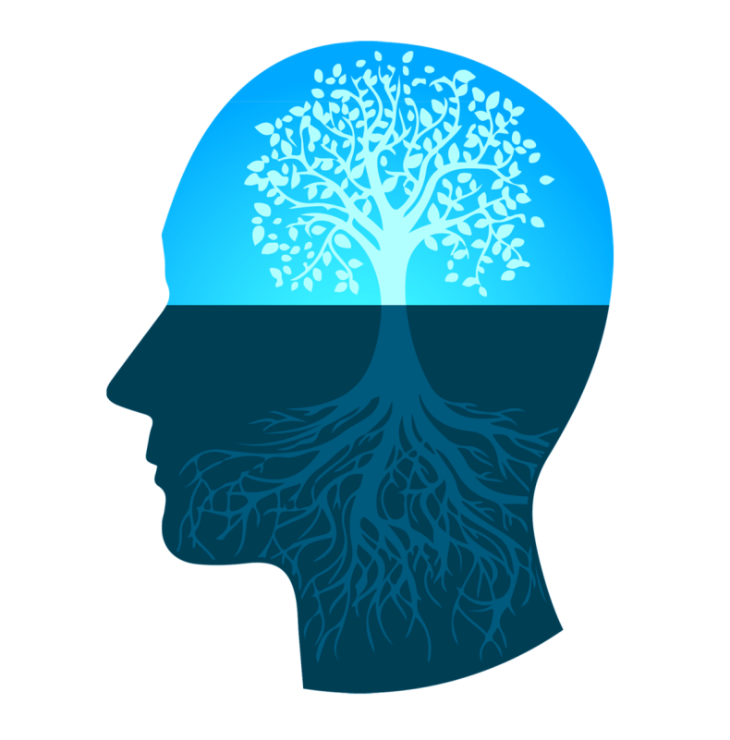

# Section 1: Introduction

Overview

# Welcome Welcome to 7 Mindset to Life Improvement!

In this workshop, you will learn

• Interpreting what mindset mean.

• Examining current goal and behaviour towards mindset

• Understand your reaction when it comes to waiting and moving forward.

•How can they adapt and show they are focused?

•Assessing consistency on their goals.

# Value of This Training

As a result of this training, you will be able to:

• Explain the importance of mindset

•Compare their current goal and behaviour to the 7 mindset

•Linking your actions when it comes to waiting and moving forward.

•Examining your action against obstacle

•How to prepare yourself to focus amidst distraction

# Contents This training consists of the following sections:

•Section 1: Introduction

• Section 2: Discussion of the different mindset

• Section 3: Group Activity

• Section 4: Wrap-up

## Purpose

This segment looks at the different mindset in life that can help to get success. See how it affects people’s outlook into things after this training.

**Self Trust Mindset**

There would be days where you can't finish the goals in time, change

your goals mid way and have hiccups on the way.

How do you keep on creating success opportunity in your life?

How would you determine if people undermine your self-trust?

When evaluating your goals, how should you speak to yourself?

**Goal Setting Mindset**

Set high goals and don't stop until you reach them.

What is your goal now?

**Patient and Courageous Mindset**

In patience mindset, you need to have _ _ _ _ _ _ _ _ _ _ _ _ _ _ _ _ _ _ _ _

Having courage and showing courage means _ _ _ _ _ _ _ _ _ _ _ _ _ _ _ _

**Focus Mindset**

The best way is to stay in the here and now and to concentrate on

everything going on in this particular moment.

When was the last time you lost focus? How did you get it back?

**Positive Mindset**

Be positive, not passive.

What are some ways you can show positivity when you wake up?

**Learning Mindset**

To radically change your life, you have to change yourself.

Every failure has something to _ _ _ _ _ _ _ _ _ _ _ _, and everything you

_ _ _ _ _ _ _ _ _ _ _ _ _ _ _ _ _ helps you grow.

**Activity:**

List down 3 things that affect your belief and goals and answer the

following questions:

HOW DOES THIS BELIEF CAUSE YOU TO ACT?

IS THIS BELIEF 100% TRUE? WHAT/WHO IS THE POSITIVE PROOF?